Case Number:

Investigator:

Complainant:

Date Complaint Filed:
Filed within 1 year of most recent PA? Yes/No

Statutory Authority: Title 10, United States Code, Section 1034 (10 U.S.C. 1034), “Protected communications; prohibition of retaliatory personnel actions,” as implemented by DoD Directive 7050.06, “Military Whistleblower Protection.”

Case Summary:

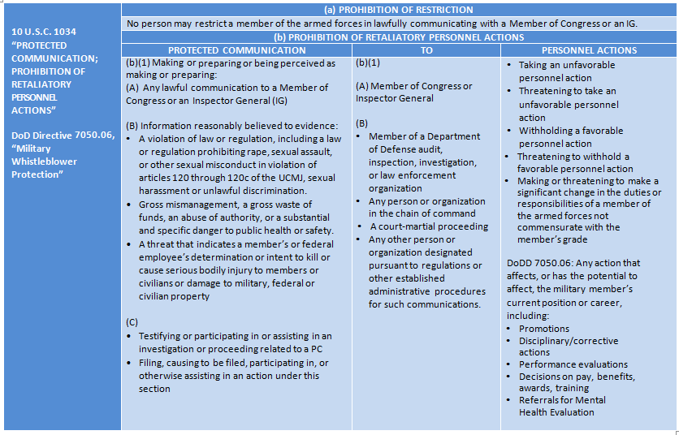
Element 1: Did Complainant make or prepare to make a protected communication (PC), or was Complainant perceived as making or preparing a protected communication?

Alleged PC #1: (add more as needed)
Description:

To whom:
Date:
Determination: Protected/Not Protected

Element 2: Was an unfavorable personnel action (PA) taken or threatened against Complainant, or was a favorable personnel action withheld or threatened to be withheld from Complainant?

Alleged PA #1: (add more as needed)
Action:

By whom? (Responsible Management Official (RMO)):

Were there other individuals involved in recommending, approving, or influencing the PA?

Date:

Determination: PA/Not PA

Possible Inference of Knowledge? Yes/No
Explain:

Knowledge Questions to ask Complainant:
- Did the RMO have knowledge of the PC or suspect you?
- What, if anything, was done in response to your PC(s)?
- How much time passed between your PC(s) and the PA(s) taken against you?
Inference of Causation: Does the complaint, as supplemented by an interview of the complainant support an inference of reprisal—that is, a causal connection between the PC and the PA? This can be met where the facts suggest the existence of one or more of the following:
• The PA followed closely behind the PC
• The PC was about something that would give the RMO motive to reprise
• The RMO expressed animosity toward the Complainant and/or the PC
• The Complainant received worse treatment than others in similar situations who have not made PCs
Possible Inference of Causation: Yes/No
Explain:

Causation Questions to ask Complainant:
- Why do you believe the action taken, withheld, or threatened was in reprisal?
- What motive would the RMO have to reprise against you?
- What were the reasons provided to you by the RMO for the action they took?

Prima Facie Allegation? Yes/No

Recommendation: Dismiss/Investigate

